ssddd3

Figure 1

Figure 2

[Document title]

Candidate Number: 7025

Candidate Centre: 11022

Riyad Ahmed

Contents

1) Analysis 2

1.1) Features that make the problem solvable methods 2

1.1.1) Problem Descriptions 2

1.2) Suitable stakeholders 2

1.3) Information gathering 2

1.4) Existing Solutions 2

1.5) Features of proposed computational 4

1.6) Limitations of the proposed solutions 4

1.7) Requirements for the solution including hardware and software requirements 4

1.8) Success Criteria 4

2) Design 5

2.1) Decomposing the Problem 5

2.2) Structure of the Solution 5

2.3) Algorithms 5

2.4) Usability features 5

2.5) Key Variables / Data Structures 5

2.6) Test data during the iterative development 5

2.7) Further data to be used in the post development phase 5

3) Iterative development of a coded solution 6

3.1) Prototype versions 6

3.2) Annotated Solution 6

3.3) Annotated Solution – same as above 6

3.4) Annotated Solution – same as above 6

3.5) Review of Solution 6

4) Testing to inform development 7

4.1) Testing at each stage of the iterative development process 7

5) Testing to inform evaluation 8

5.1) System Testing and End user testing 8

6) Evaluation of solution 9

6.1) Evaluate the solution 9

6.2) Further development. 9

6.3) Effectiveness of usability features. 9

6.4) Maintenance issues and limitations of the solution. 9

6.5) Limitations and potential improvements / changes. 9

# 1) Analysis

## 1.1) Features that make the problem solvable methods

### 1.1.1) Problem Descriptions

[name] is a manager at [company] that specializes in journals about gaming. They are a startup company and want to add more to the gaming field. They were founded recently with only a few members just have grown exponentially in the past couple of months. (Need more detail)

They need a website for their readers so they can review games that they have played and expand their knowledge and content when making articles about games.

They have also requested a way to search and sort games alphabetically, games released after dd/mm/yyyy or for x console. They also wish to add a group system for clients to join groups, discuss about common games the group plays and to organise tournaments between them and other groups.

## 1.2) Suitable stakeholders

|  |  |  |  |
| --- | --- | --- | --- |
| Stake Holder | Role | Interaction | Availability |
| Samuel Naylor | Journalist | Reviewing the program | Daily |
| Nathan Adelakun | Owner | Reviewing the program / Hired Specialists | Twice a month |
| Navid | CEO | Reviewing the program / Hired Specialists | weekly |
|  |  |  |  |

## 1.3) Information gathering

I carried out an interview with the clients and they want an application that allows users to review games that they have played to let other users know what X game is like. They also want to include a Syndicate system to allow uses to join a group and discuss about games and organize in-clan and clan-vs-clan based tournaments with the brackets created internally by the program. On top of this, they wish to add a forum segment to write tutorials and help others that are stuck in a game. They also want to add stars for the rating of the game.

I also carried out a questionnaire for the different styles and colour schemes for the app. The majority want a simple, semi-minimalistic design to the app with a showcase of the game up front as soon as the app loads, with the name, star rating and most popular review of the game being displayed, the game will then change after about 5 seconds.

## 1.4) Existing Solutions

Forum system

Syndicate system / clan system

Reviews stored in a database

Accessibility for logins

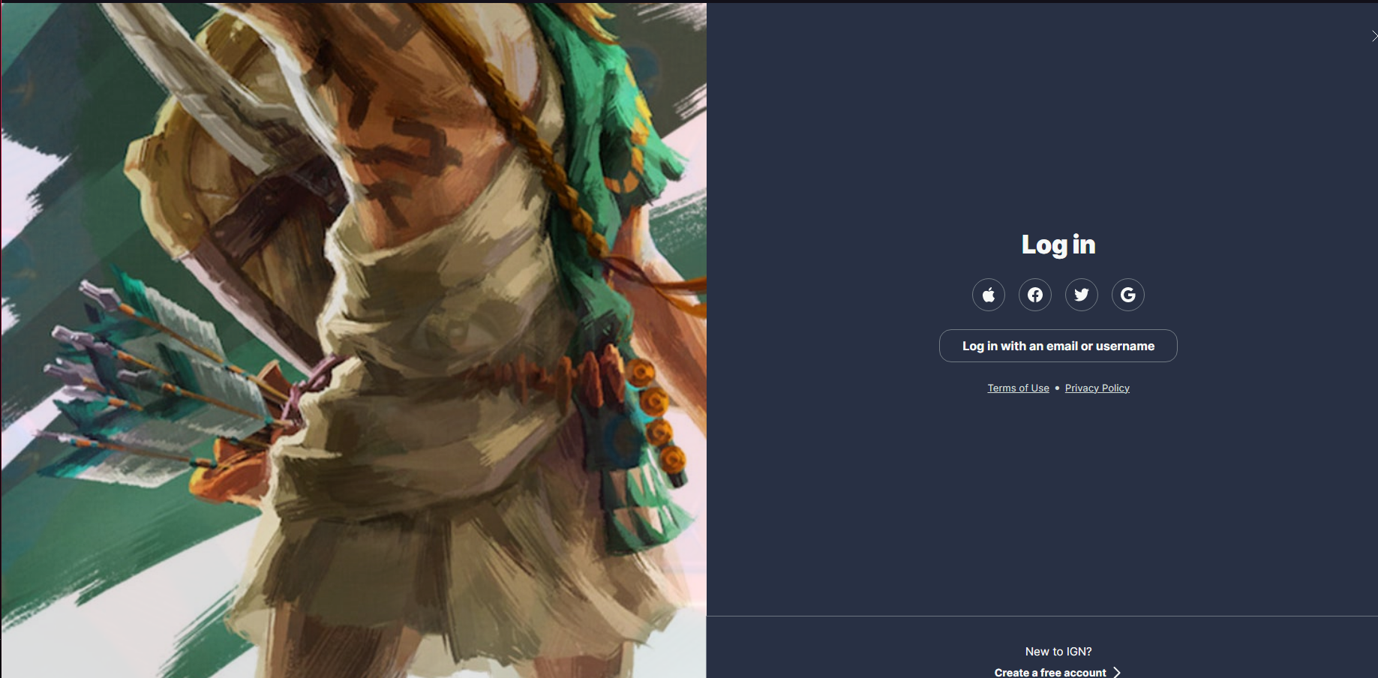

**Figure 1.1**

IGN’s login page gives us many third-party ways to login like using your google or Facebook account, which is a great way to login in as many people already have accounts from these third-party companies which have a continuously updated API so many people can login using these methods as an alternative than registering straight to IGN. The image to the side of the login page changes constantly to reflect new games and other pieces of media. They chose a simple colour palette of two colours, a dark blue and white, which doesn’t distract the end user. The UI itself is clean and simple, no distractions and to the point. There is no unnecessary extras added to the login page like advertisements or pop-ups.

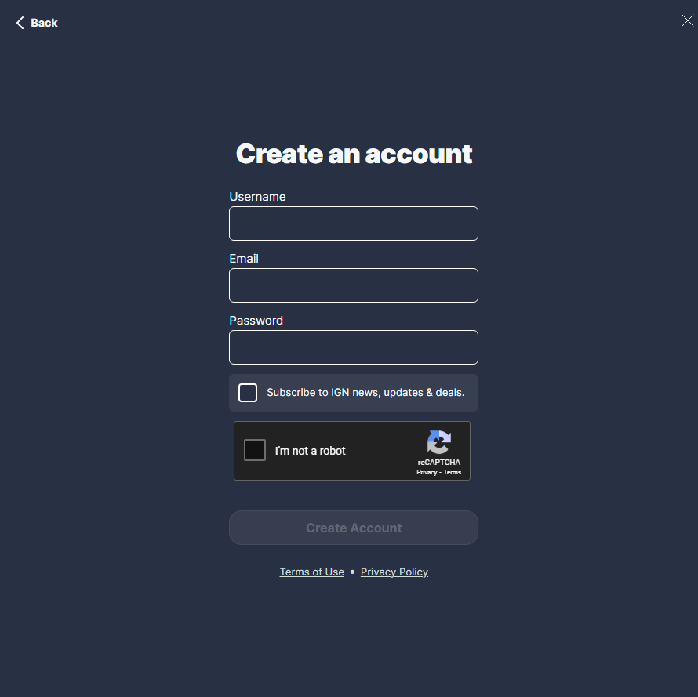

**Figure 1.2**

The Register page includes a username being a name to each and every person which with people a sense if uniqueness and highly customizable by using many different Unicode characters but has to be different to anyone else’s username, an email address which allows emails to be sent from the website into the users inbox if something big happens, like the new final fantasy being released or newsletters being sent. After a new user makes an account, a prompt to sign up to the newsletter will appear. Included in the register process is a ReCAPTCHA box to prevent bot accounts from being made to help prevent DDoS attacks and stops abuse of free trails. There is a “register” button that signs you up to the websites page which will add the login details to a database.

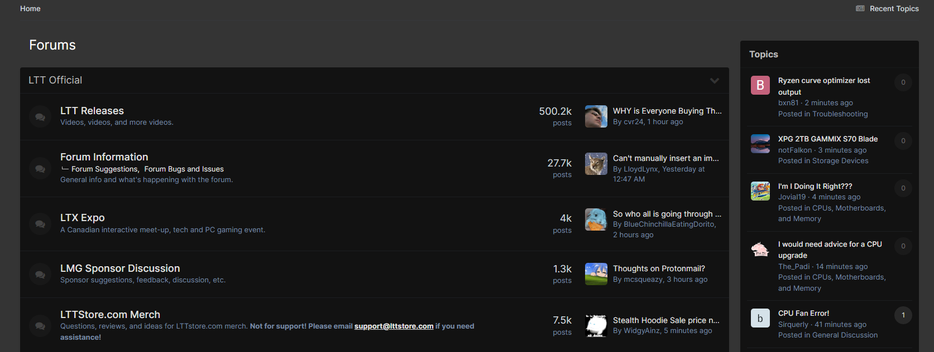

**Figure 2.1**

Linus Tech Tips is a forum website that allows user to post topics as a guide to help others, customers and clients that require help in all aspects related to technology or general inquires. The forum page is split into multiple sections, showing hot topics, guides and new forums that are made. Furthermore, each post has a tag to split them into their respective categories so they are easier to sort out and to search for. One thing I dislike about [**Figure 2.1**] is the basic, two-toned colour scheme. The client wants to change this by adding a frosted box on top of the post and a colour at the corner of the post to show what category the post is sorted into.

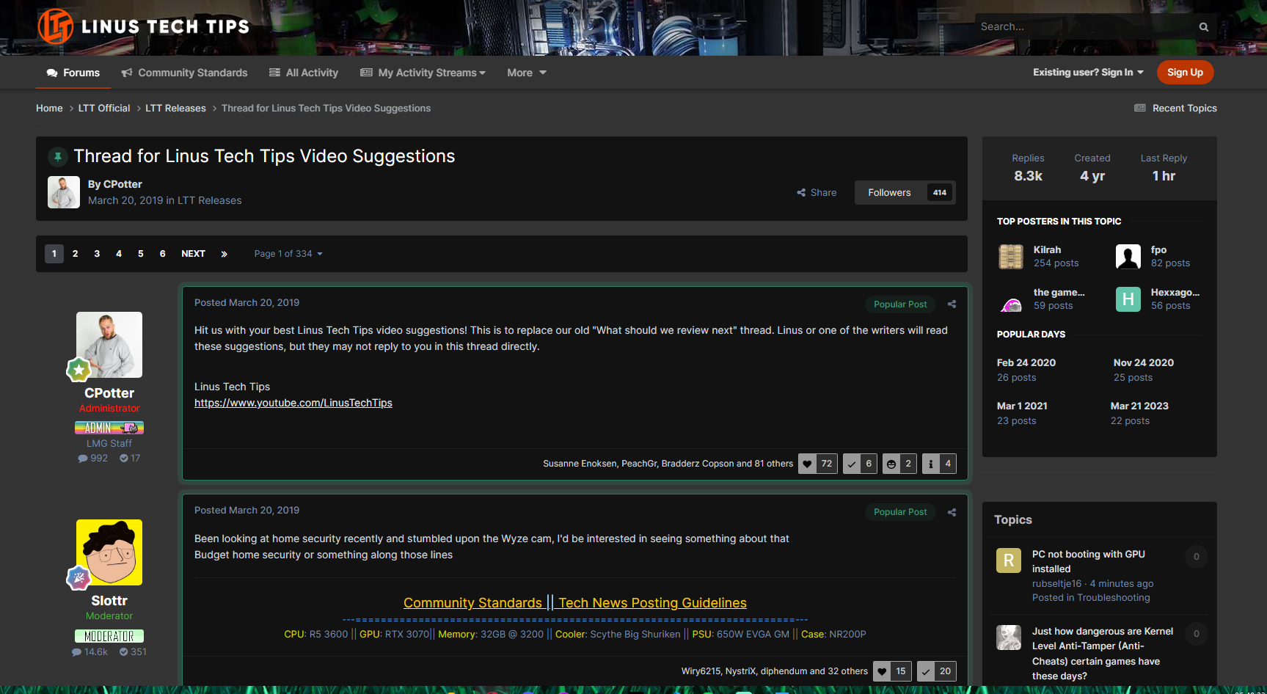

**Figure 2.2**

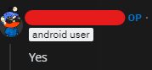

**Figure 2.3**

In [**Figure 2.2**] the user that posts a query is displayed up top, the client wants to add this add an indicator such as “OP” o show they are the original poster of the question like Reddit [**Figure 2.3**]. There are also user ranks, showing if the user is an Admin, Moderator or a regular user, to distinguish between users and power users.

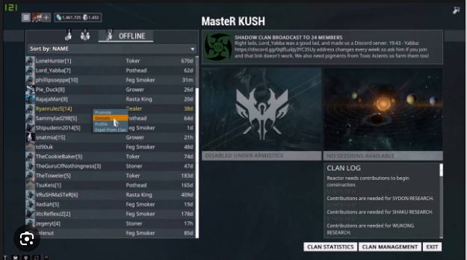

**Figure 3.1**

In [**Figure 3.1**] a clan system in the game ***Warframe*** is shown. This page shows a Clan (Which the clients want to add and rename it to “Syndicates”) with the name of the clan on the top, members list on the left, clan description and emblem top right with activities underneath and at the bottom is a log of actions that has happened within the clan and regarding the clan itself. Each clan as a user ranking system such as regular members, admins and founder. Admins and the Founder can manage the other users such as muting them, kicking them from the clan or banning them from the clan. The clan system is used for competitions with and against of clans which is why the clients would like to add this to the application.

## 1.5) Features of proposed computational

## 1.6) Limitations of the proposed solutions

|  |  |  |
| --- | --- | --- |
| Number | Requirements | Justification |
| 1.1 | Login page |  |
| 1.2 | Hashing and encryption of passwords |  |
| 1.3 | Username and display names |  |
| 1.4 |  |  |
| 1.5 |  |  |
| 1.6 |  |  |

## 1.7) Requirements for the solution including hardware and software requirements

### 1.7.1) Software Requirements

|  |  |  |
| --- | --- | --- |
| Number | Requirements | Justification |
| 1 | Pascal (Lazarus) | The coding language of the program. |
| 2 | Microsoft Word | The software used for the documentation for the project |
| 3 | Microsoft Windows 11 | The operating system designed for the program. |

### 1.7.2) Hardware Requirements

|  |  |  |
| --- | --- | --- |
| Number | Requirements | Justification |
|  |  |  |
|  |  |  |

### 1.7.3) Design and Functionality Requirements

|  |  |  |
| --- | --- | --- |
| Number | Requirements | Justification |
|  |  |  |
|  |  |  |

## 1.8) Success Criteria

# 2) Design

## 2.1) Decomposing the Problem

## 2.2) Structure of the Solution

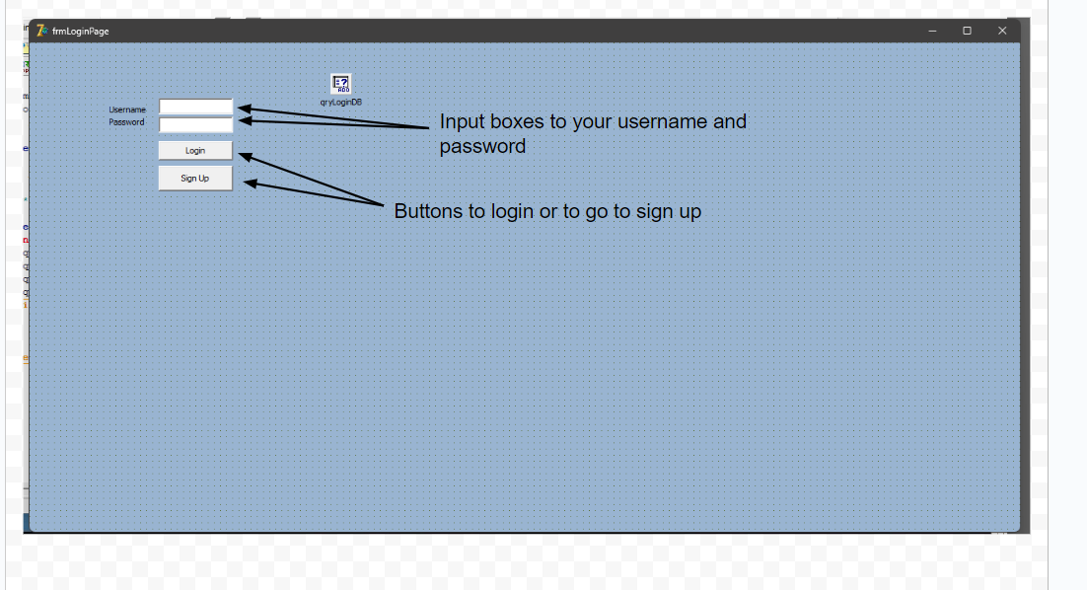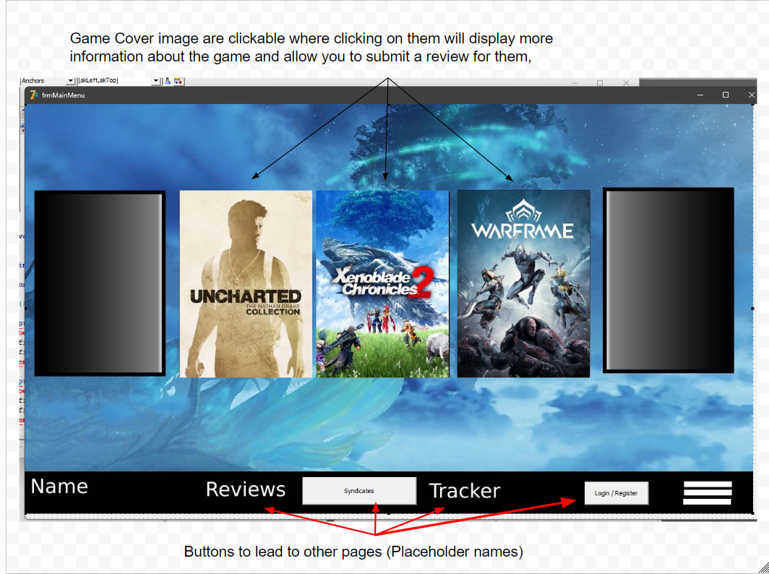

## 

## 2.3) Algorithms

## 2.4) Usability features

|  |  |
| --- | --- |
| Usability feature | Justification |
| Black text for the buttons | The black text makes it easier to read against the grey buttons. |
| White text and a black box for information | Since the game pages have custom images, a box with contrasting text colour is required to allow the clients and users easily read the information. |
| Boxes being the same size | For design aspect to make the interface look more sleeker and look cleaner. |
|  |  |
|  |  |
|  |  |

## 2.5) Key Variables / Data Structures

## 2.6) Test data during the iterative development

## 2.7) Further data to be used in the post development phase

## 

# 3) Iterative development of a coded solution

## 3.1) Prototype versions

Annotated screenshot of the main page

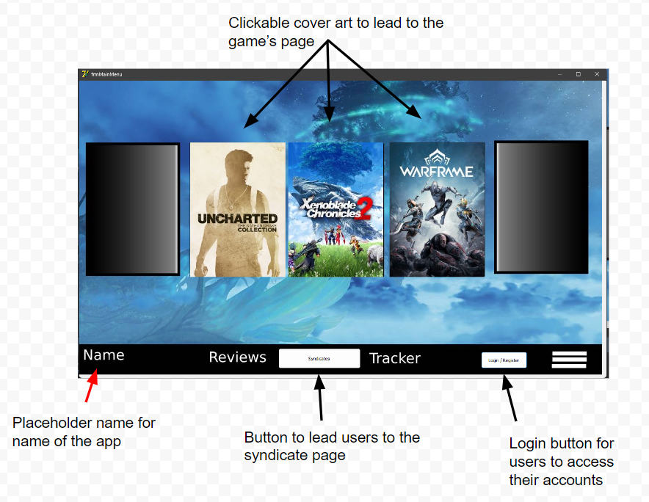

Code for the buttons and clickable game cover art

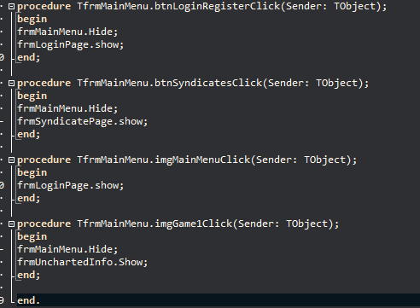

Annotated screenshot of the login page

## 

Code for the buttons

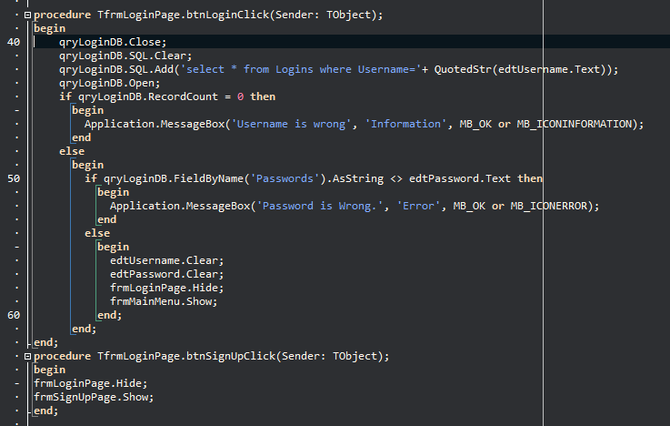

Annotated screenshot of the sign-up page

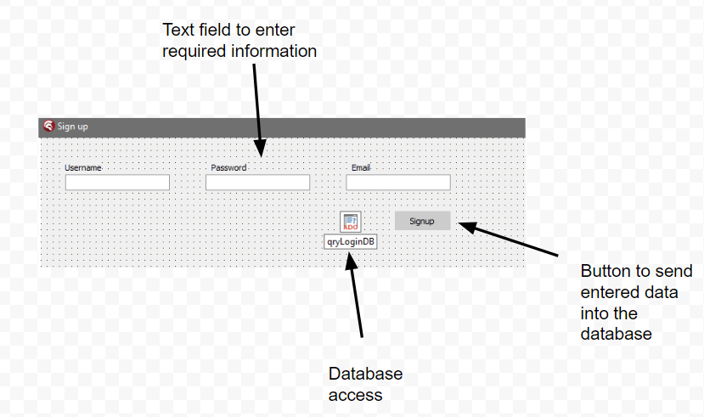

There are currently no checks in the sign up page which is a requirement that will be added in the next prototype.

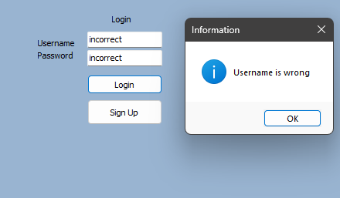

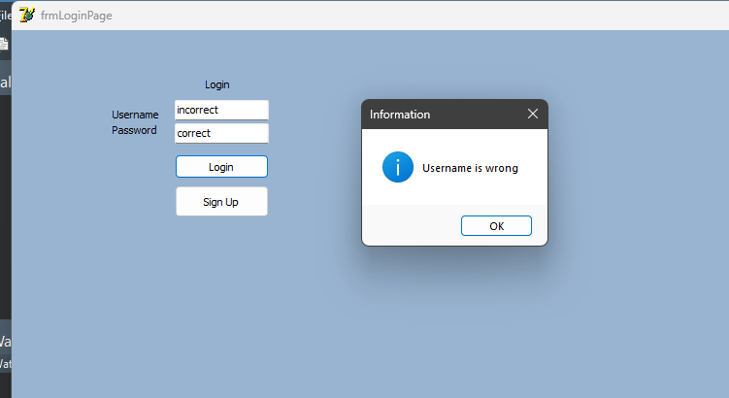

Program stops user from entering further when incorrect user name is entered. Program also mentions only the username is wrong when both are wrong

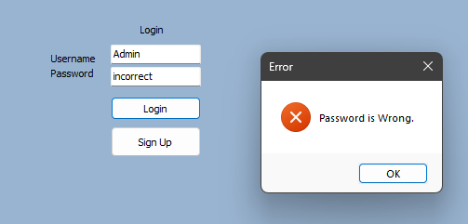

Program notifies user when the password is incorrect.

## 

When clicking on the game cover art, it brings you a page with a quick synopsis.

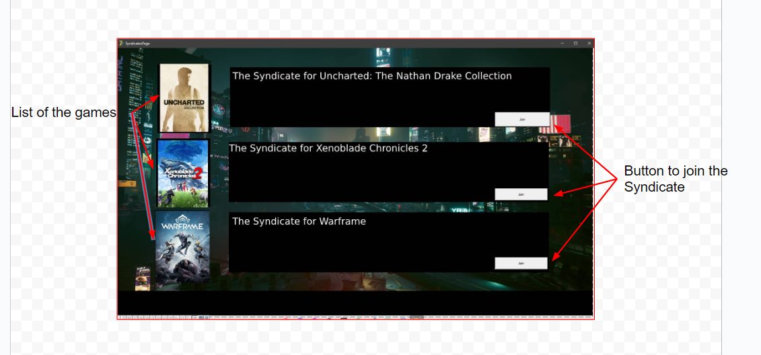

Syndicates are groups you can join to get information of updates to the games but due to the time constraint, the news will not be added in the initial release. The page is also missing an option to return to the previous page.

## 3.2) Annotated Solution

## 3.3) Annotated Solution – same as above

## 3.4) Annotated Solution – same as above

## 3.5) Review of Solution

# 4) Testing to inform development

## 4.1) Testing at each stage of the iterative development process

# 5) Testing to inform evaluation

## 5.1) System Testing and End user testing

# 6) Evaluation of solution

## 6.1) Evaluate the solution

## 6.2) Further development.

## 6.3) Effectiveness of usability features.

## 6.4) Maintenance issues and limitations of the solution.

## 6.5) Limitations and potential improvements / changes.